**B2B sales pipeline**

**﻿(CRM Sales Opportunities)**

CONTENT OF ANALYSIS

-Total Revenue

-Average Revenue

-Total Employee

- Total sales Agent

-Engage Year By Product

-Close Year By Product

-Map On Accounts And Office Region

-Map On sales Agent And Regional Office

-Map on Office Location

-Close Value By Product

-Product By Regional Office

-Engage Year By Deal Stage

-Close Year By Deal Stage

-Deal Stage By Manager

-Engage Year By Manager

-Close Year By Manager

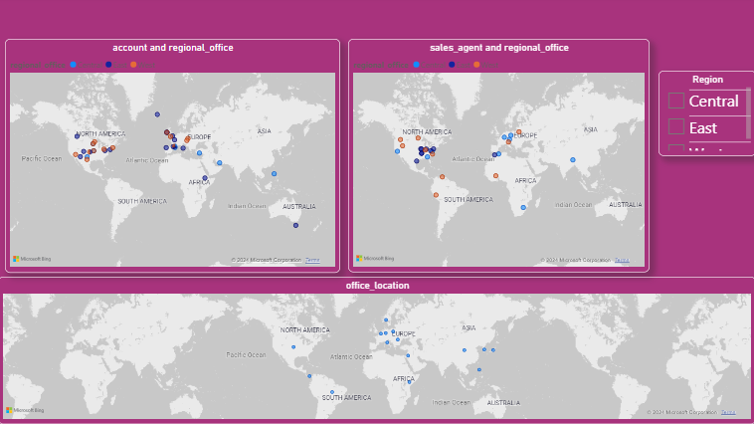

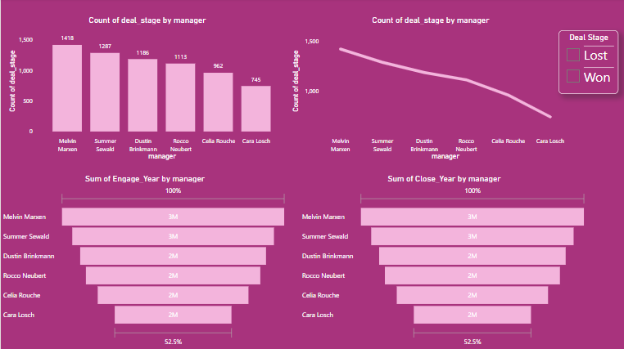

CONCLUSION

CRM Sales Opportunities

B2B sales pipeline data from a fictitious company that sells computer hardware, including information on accounts, products, sales teams, and sales opportunities.

Analysis How is each sales team performing compared to the rest

How many sales agents and managers Are lagging behind

It also identifies yearly and monthly trends

It shows products that have better win rates and those that have losses